Model Development Phase

Date | 08 February 2026
Team ID | LTVIP2026TMIDS39313
Project Title | Advancing Nutrition Science through GeminiAI – NutriAssist AI
Maximum Marks | 10 Marks

Initial Model Training Code, Model Validation and Evaluation Report
In the NutriAssist AI project, no custom model training is performed. Instead, a pre-trained Gemini AI model is integrated to generate personalized nutrition plans and health guidance.
Initial Model Training Code:
Model Selection and Initialization
The Gemini Flash Lite (models/gemini-flash-latest) model is selected because:
- It is lightweight and optimized for fast inference
- Suitable for real-time personalized nutrition generation
- Efficient in handling structured health prompts
- Cost-effective for scalable deployment
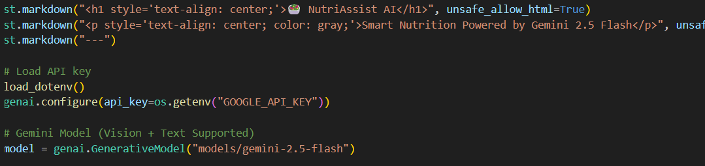

Model Validation and Evaluation Report:
Model | Summary | Training and Validation Performance Metrics
Gemini Flash Lite | Pre-trained generative language model optimized for fast text generation | Nutritional relevance, medical appropriateness, personalization accuracy, adherence to calorie targets, coherence, clarity, response time

